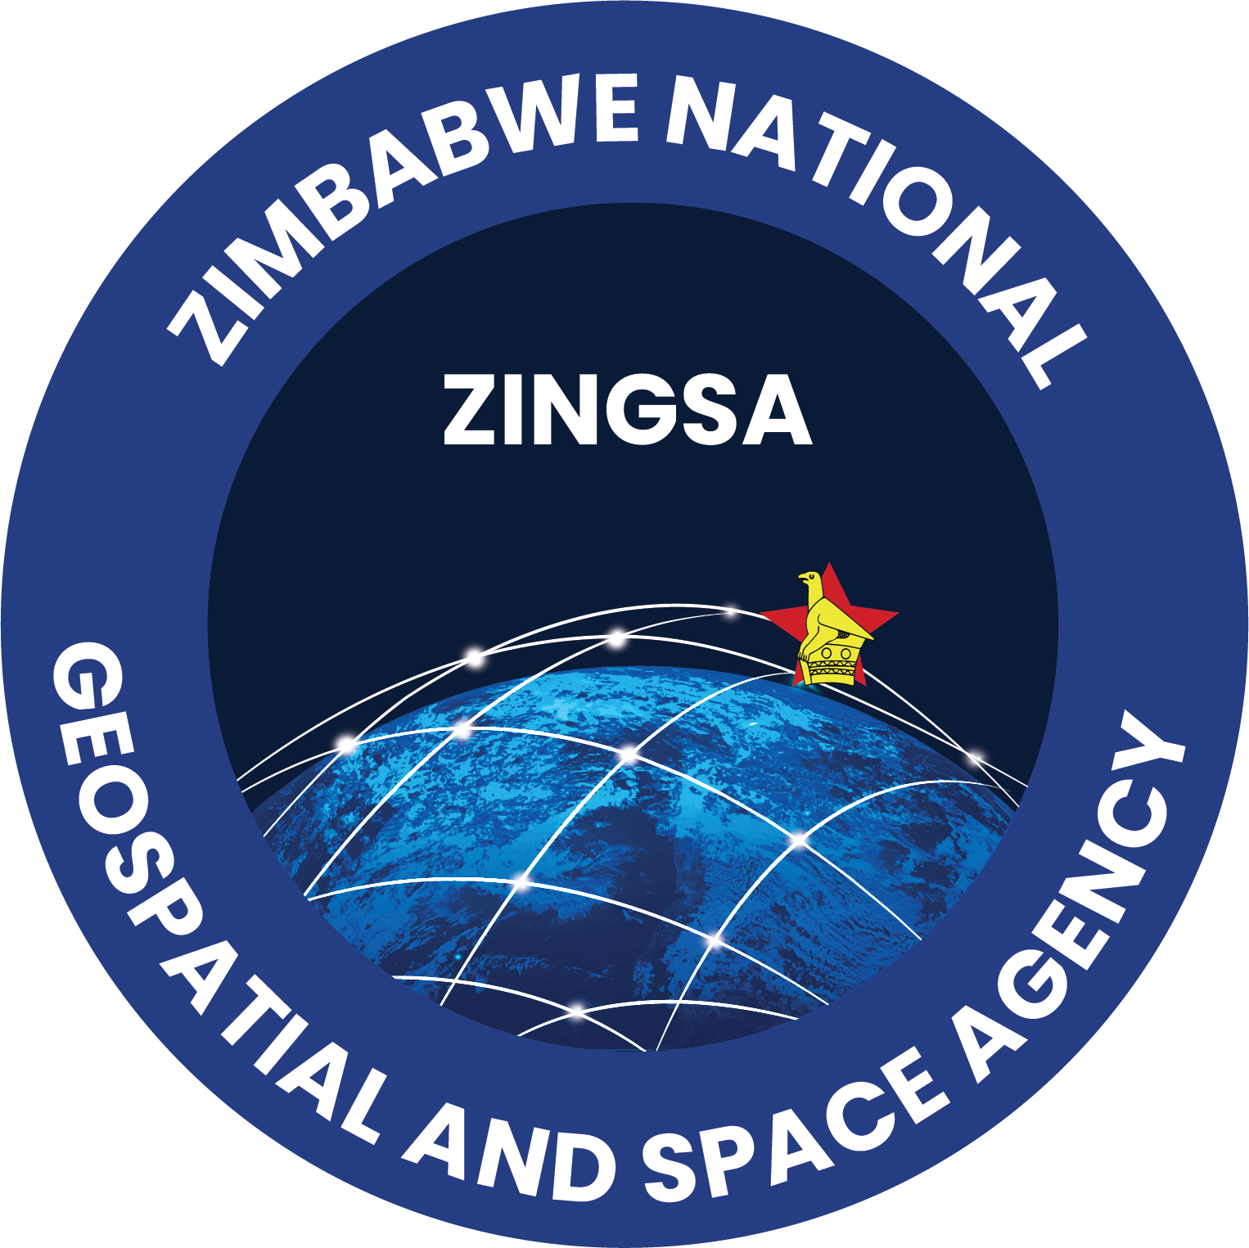
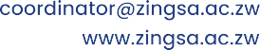


INFORMATION & COMMUNICATION TECHNOLOGY (ICT) DEPARTMENT
Internal Memorandum
To: ICT Manager & Director General
From: ICT Department
Prepared by: Solomon Mukonda
Date: 15-04-2025

Subject: Response Proposal — AI-Powered Recruitment Management System (ATS)

1. Introduction
Following the request submitted by the Human Resources Management (HRM) Department regarding the development of an automated Recruitment Management System, the ICT Department is pleased to confirm that the proposed AI-powered Applicant Tracking System (ATS) has been developed in line with the specified requirements and is now ready for testing.
This document is submitted to seek management approval for this system prior to handing it over to the HRM Department for final user acceptance testing and deployment planning.

2. System Overview
The Recruitment Management System is designed to enhance the efficiency, accuracy, and fairness of ZINGSA’s recruitment process by:
- Automating job posting, application collection, shortlisting, and candidate evaluation.
- Enabling HR to post vacancies internally and externally, receive applications, review candidate profiles, record notes, and track recruitment progress in real-time.
- Improving transparency and applicant experience through automated updates and status notifications.

3. System Benefits

Operational Efficiency: Automation of job posting, application intake, and shortlisting significantly reduces HR workload.

- Bias Reduction: Anonymized candidate screening ensures fair and objective evaluation.
- Improved Matching: AI-powered filtering for precise candidate-to-position matching.
- Enhanced Candidate Experience: Clear status notifications, timely feedback, and simplified applications.
- Strategic Insights: Built-in analytics enable better planning and tracking of recruitment performance.
- Accountability & Transparency: Audit-ready record of shortlisting decisions and feedback.

4. Project Status
The system has passed internal development testing and is now ready for formal user acceptance testing (UAT) by the HRM Department, pending ICT management and Director General approval.

5. Project Considerations & Recommendations
- User Interface Enhancement: To ensure the system’s user interface aligns with ZINGSA’s corporate image and enhances usability, the procurement of a premium UI template is recommended.
- Hosting & Security Planning: Post-approval, the system will require secure deployment either on dedicated in-house servers or cloud infrastructure in line with ZINGSA’s data protection policies.

6. Conclusion
The ICT Department recommends proceeding with testing and deployment planning for the Recruitment Management System. The solution promises to improve operational efficiency, reduce human error, improve transparency, and ensure fair candidate evaluation — ultimately modernizing ZINGSA’s recruitment operations.
We submit this proposal for your review and approval.

7. Approval & Endorsement
Name | Designation | Signature | Decision
____________________________ | ICT Systems Administrator | __________ | ☐ Approve ☐ Decline
____________________________ | ICT Manager | __________ | ☐ Approve ☐ Decline

Recommended/ Not Recommended

P. Gweme: _______________________________Date _______________________________
DIRECTOR GENERAL
End of Memorandum
Issued by: ICT Department

